Nguyễn Thanh Xuân Tùng
ITITIU16144

Introduction to AI
Lab 02

1) Load Lab 1_Read_Analysic_Data file, open and Run Read_data_csv.ipynb file
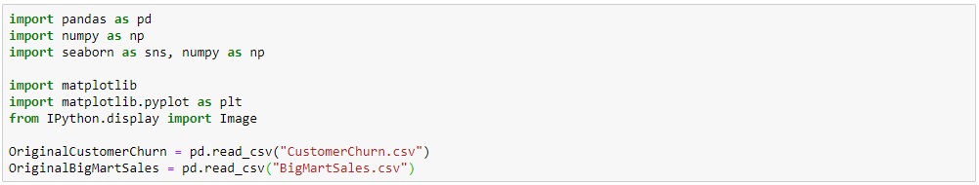

2) Show the Dataset Customer Churn and BigMartSales
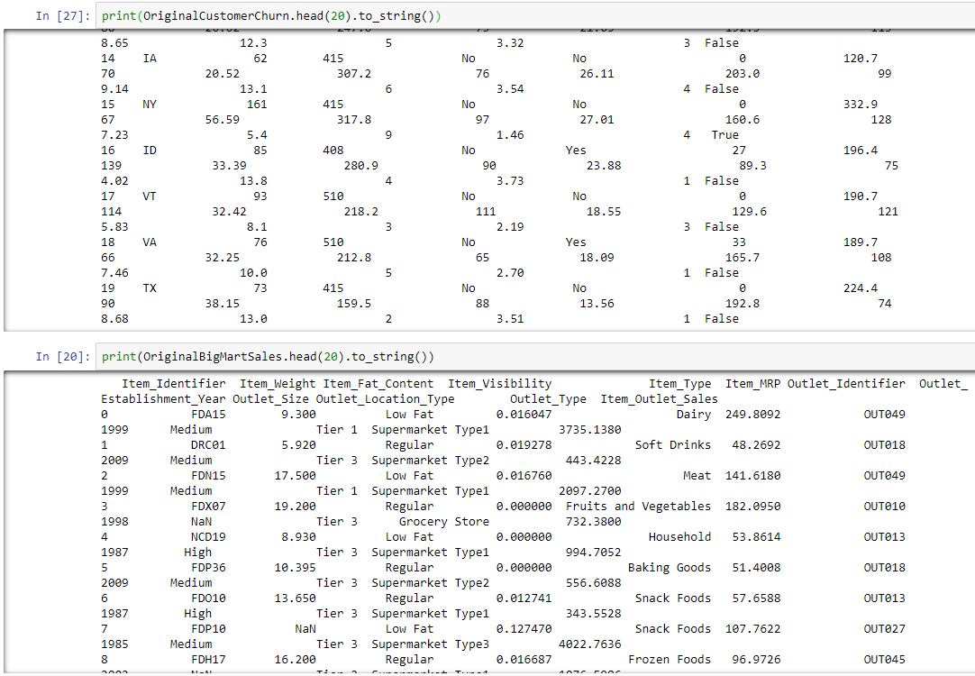

3) Use isnull().sum() to check the percentage of missing values of 2 Datasets in each variable
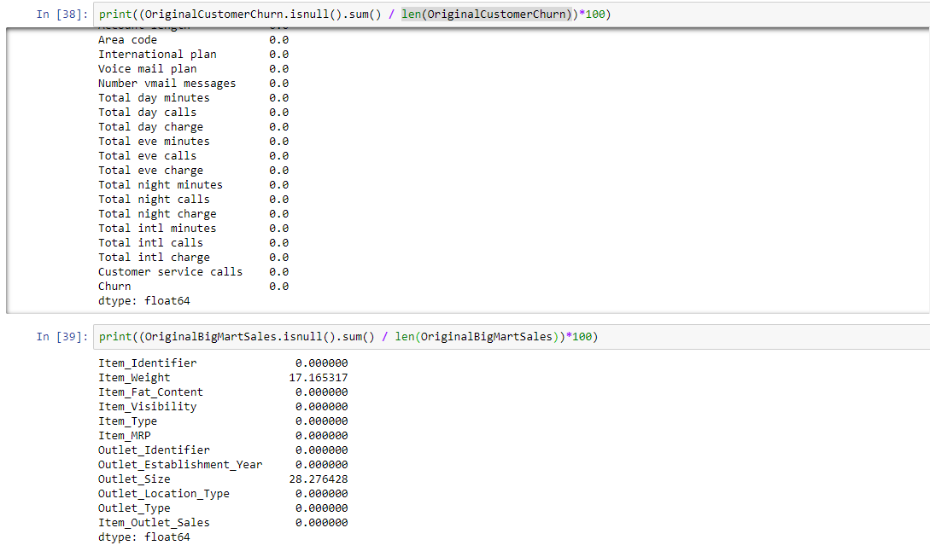
5) Write down all variables that are missing data
CustomerChurn missing variable: 0
BigMartSales missing variable: 2 (Item_Weight: 17.16%, Outlet_Size: 28.28%)

6) Filling missing data:
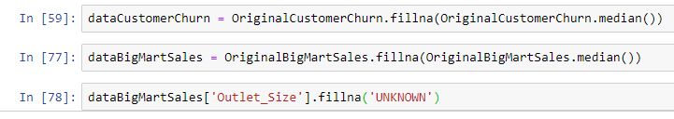
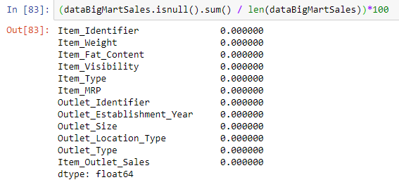

7) Exploratory Data Analysis
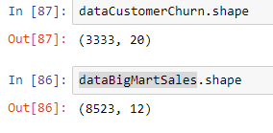

8) Preprocessing
In CustomerChurn
Collect at least 3 features (3 factors) that they have the high mean and std values
 | Total night minutes | Total eve minutes | Total day minutes
Mean | 200.872037 | 200.980348 | 179.775098
Std | 50.573847 | 50.713844 | 54.467389

Choose one of three features above to train
